Let us start with saving – PUT data on the server:

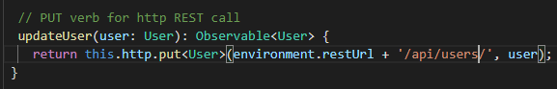

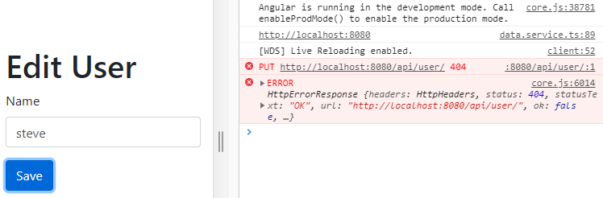

Server is off. So, start the Spring Boot application.

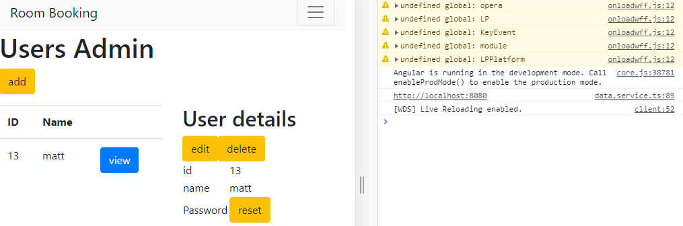

No errors, but there is no evidence of saving either

But refresh the page

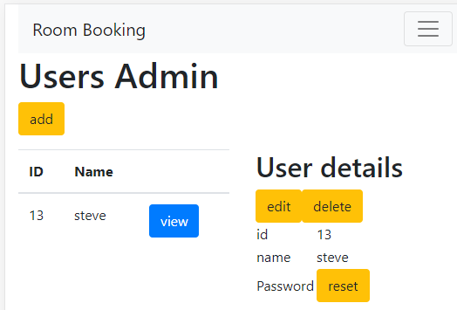

It has worked

But, we now know to refresh programmatically to see the new user save in action

So, the Edit component is a child of the Users component. If we create an event in the child

Component and bind it to the parent, then the child will be updated with the parent.

**Create a dataChangedEvent in the Edit class:**

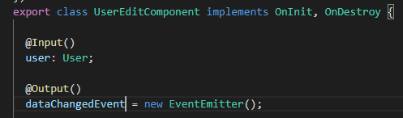

Fire the event with Saving or OnSubmit()

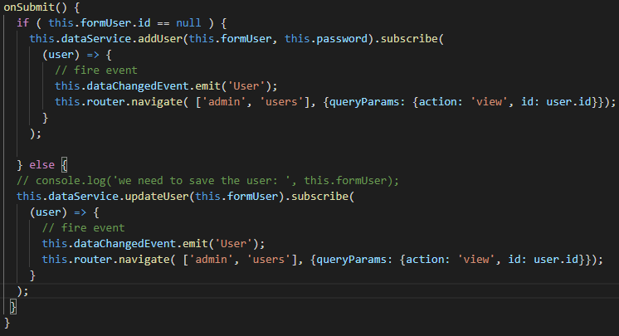

We are method binding so, use round brackets.

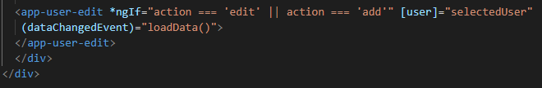

Let us test this:

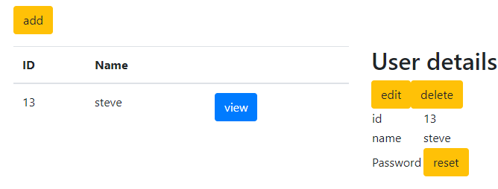

Switch back to Matt:

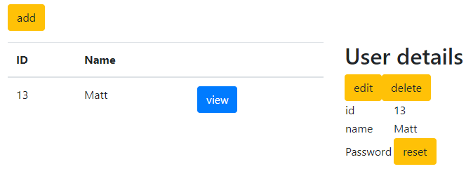

Added a Saving message and error:  
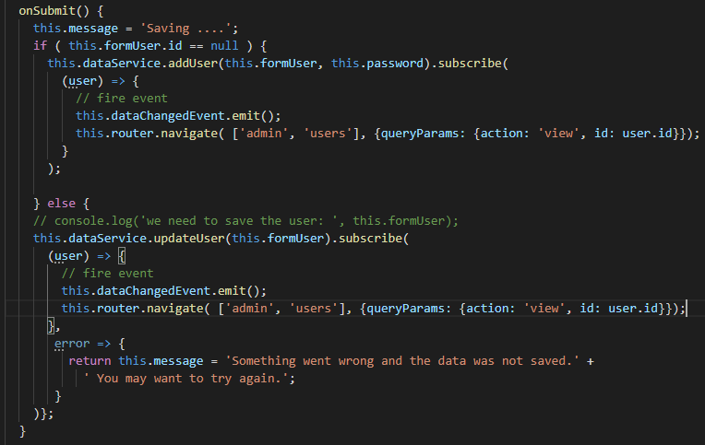

Put a delay in the server so we can see the Saving…

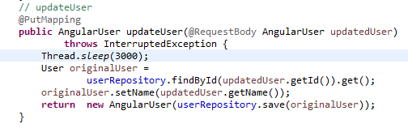

Now, change Matt to Paul

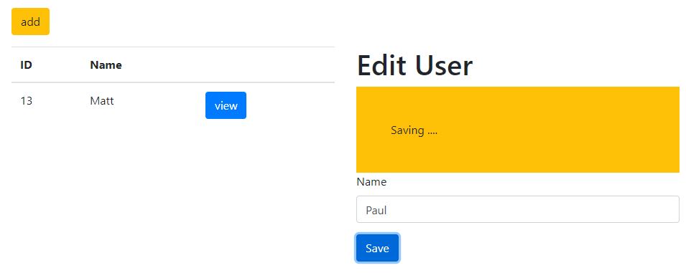

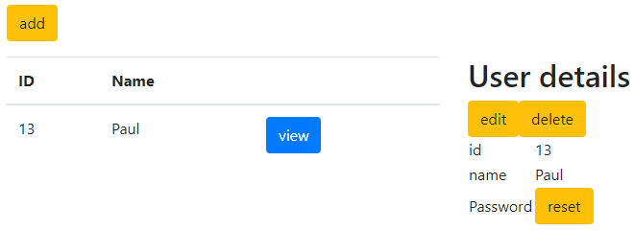

Now, let us demo the Error message

